INTRODUCTION

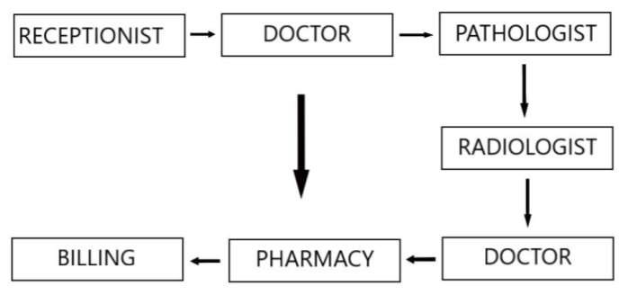

The above diagram depicts the Patient Journey Cycle. Patient Journey Cycle is the cycle or the set of procedures a normal patient has to undergo in case of a visit to a hospital, a health center or a clinic. The above diagram depicts the people the patient interacts with during the various times of his visit to a hospital.

STAGE 1: A patient first enters the hospital or the clinic ad talks to the receptionist regarding the availability of the doctor. The receptionist after checking the availability of the doctor puts the patient in the OPD (Out Patient Department) queue. OPD queue is the queue maintained by the receptionist in order to make sure that the patient coming first has the opportunity to see the doctor first (First Come First Serve).

STAGE 2: The patient after waiting for his turn to see the doctor will go to see the doctor. The patient then describes about his issues to the doctor and the doctor. The doctor based on the symptoms predicts the problem based on the symptoms or sends the patient for some tests or scans.

STAGE 3: Pathologist is the person who takes the blood samples of the patient and diagnosis it for any virus or microorganism which will help in predicting any disease the patient is currently undergoing.

STAGE 4: The next stage is a Radiologist. This is a step which the patient has to undergo in order to get some scans of any of the body part. The radiologist gets involved when the doctor wants to check anything inside the body of the patient.

STAGE 5: The patient after this waits for the reports from the Radiologist and the Pathologist and after obtaining the reports of the result goes back to the doctor again for getting the final disease and also the drugs for that disease.

STAGE 6: The next stage in the cycle is the pharmacy which either the patient directly after the doctor predicts his problem and prescribes the medicines.

STAGE 7: The final stage is the billing. The patient pays any money which has been pending on his behalf to the hospital.

Existing System Analysis: Currently the system of the Patient Journey Cycle installed in VIT is that when the student faces a problem, he or she tells the security guard of that particular building to call the ambulance. The ambulance comes and the patient is taken to the Health Center. The patient then gives his ID card for a registration and the fee of which he has to pay initially. The patient is given a booklet in which the doctor enters the symptoms, the predicted tests and the medication which has to be later purchased by the pharmacy. However, first the vitals of the patient are taken by the nurse at the health center. Then only the patient is sent to the doctor.

Problems

1. The entire system requires the patient to pay the money multiple times rather than a single bill at the end of the transaction.
2. The booklet has to be maintained by the patient when he goes to visit the doctor the next time.
3. The medical history of the patient is not available to the doctor or even the patient himself.
4. The hostellers have to call the respective Hostel Warden separately and then make sure that the attendance of the hostel is maintained properly.
5. There is no cohesion between the various domains of the Health Center working together.
6. The log for when the patient entered and when he left the health center has to be maintained

manually on a register which needs to be regularly checked.

SURVEY & ANALYSIS

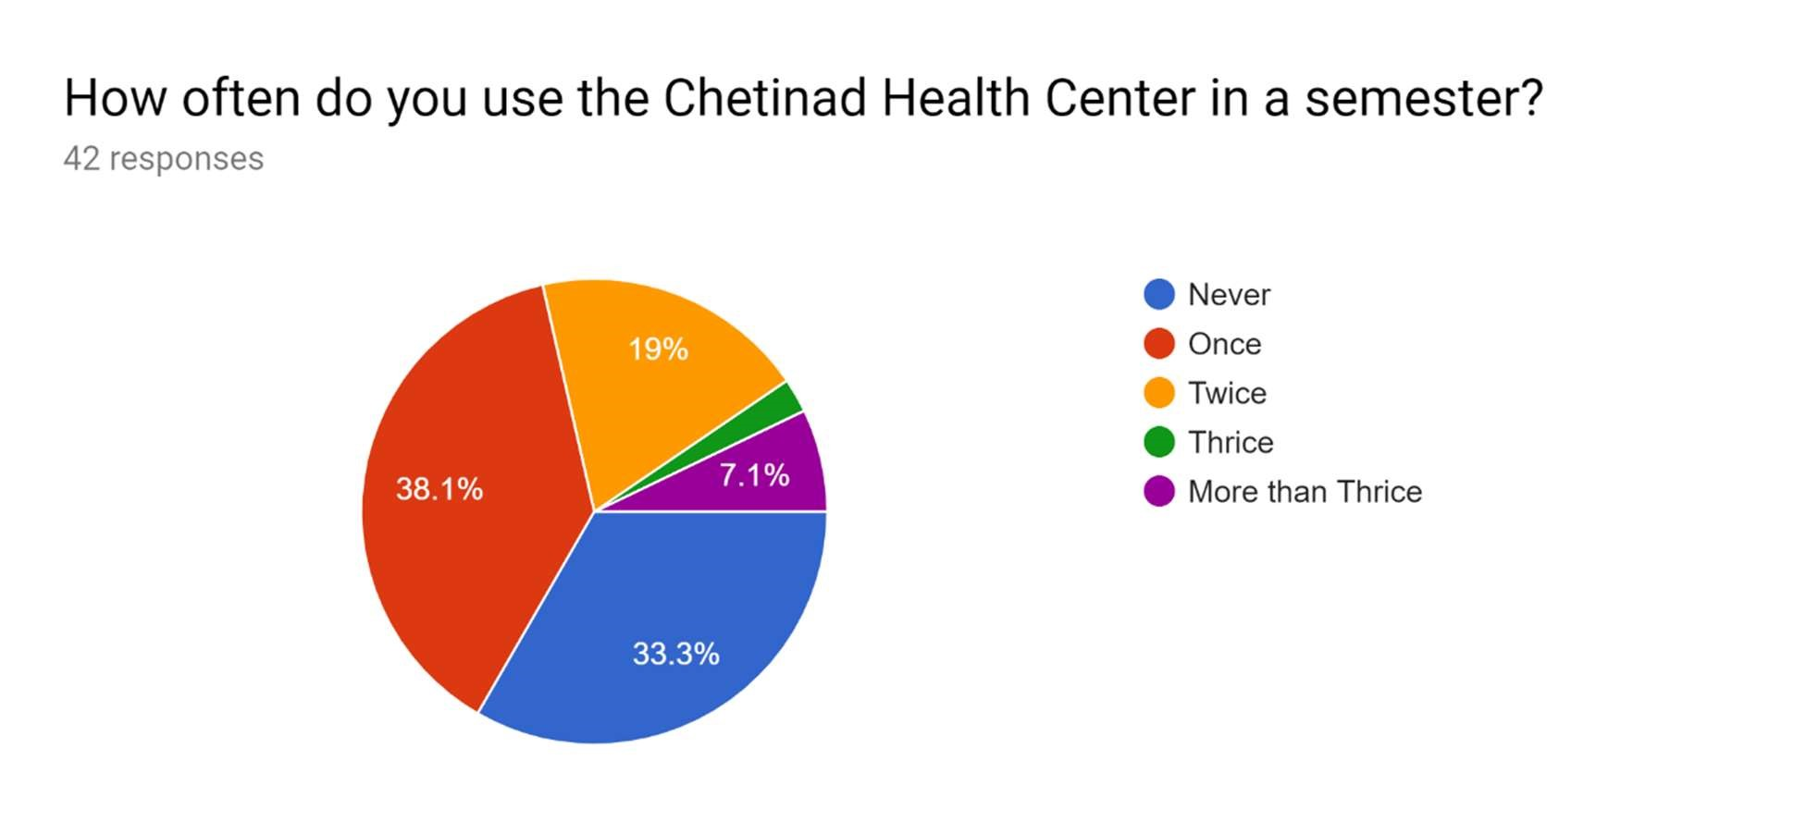

The response clearly shows that the CHC is visited by 2/3rd of the students every semester. The number of visits may vary from patient to patient.

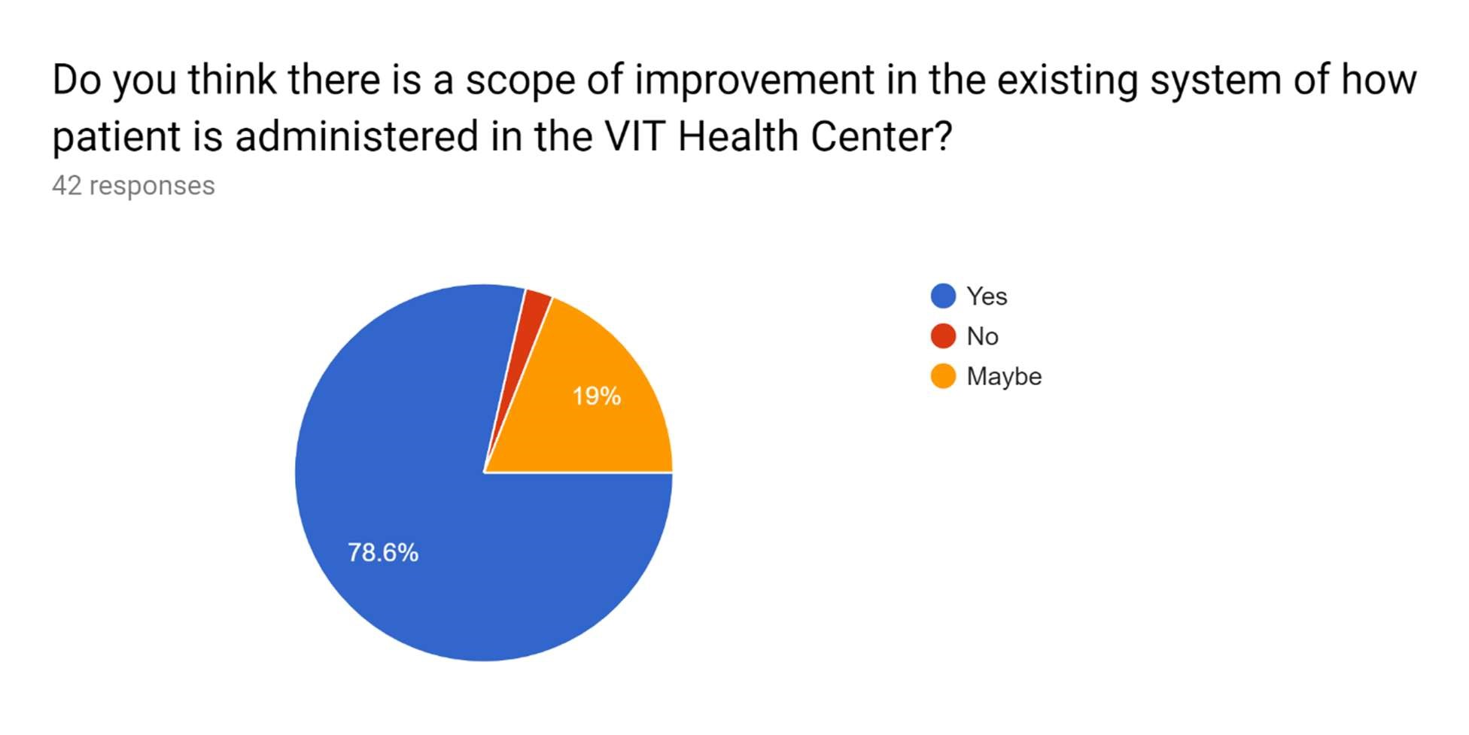

The response clearly shows that a majority of the patients believe that there is some scope of improvement in the existing system used by the CHC.

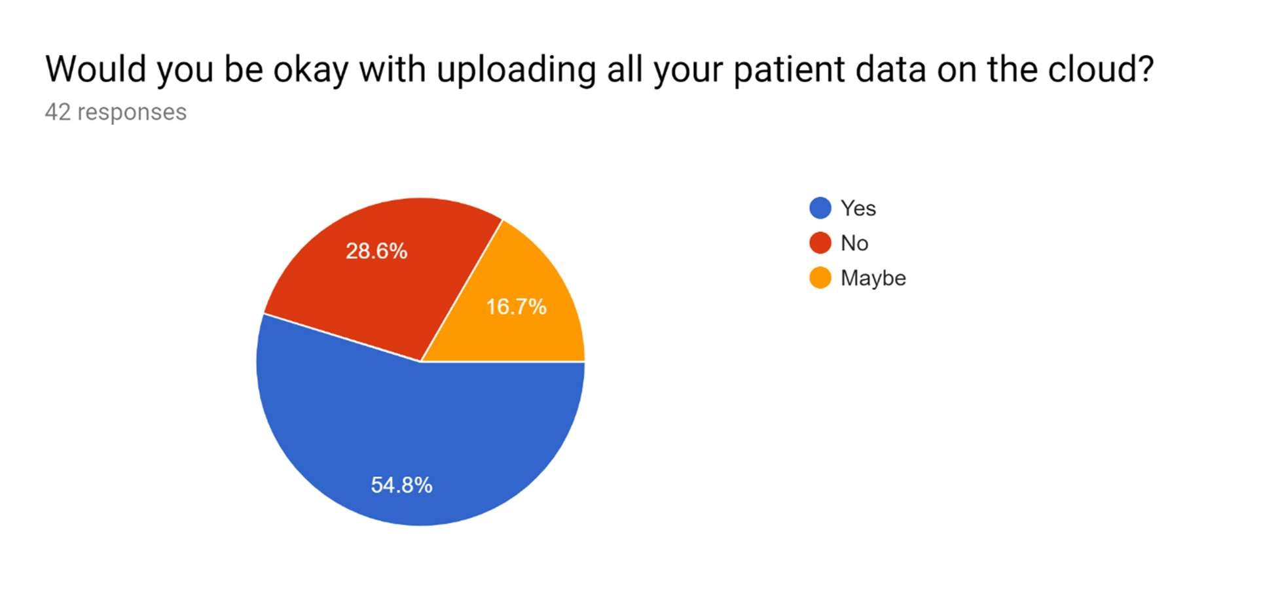

The response shows that although a majority of patients are ready to upload their patient record to the cloud, there is a fair share of 1/4th of the total that are skeptical towards this move.

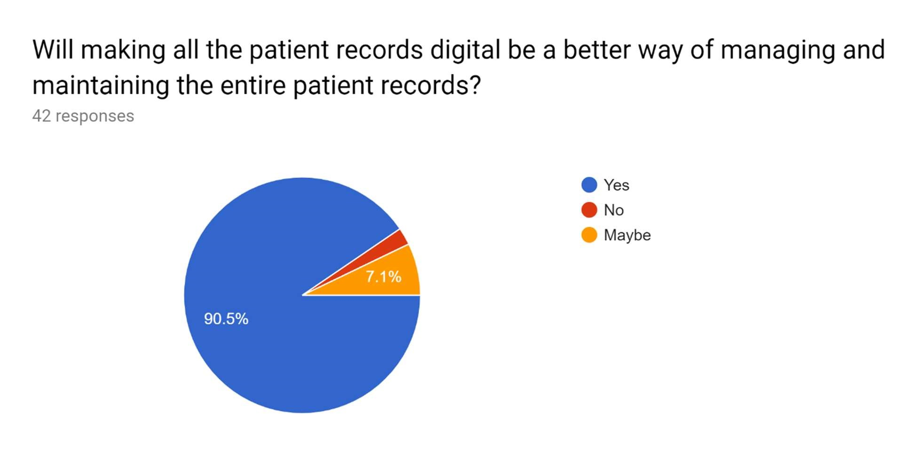

The response clearly shows that almost everyone accepts that a digital patient record system can

make the management and maintenance more efficient,

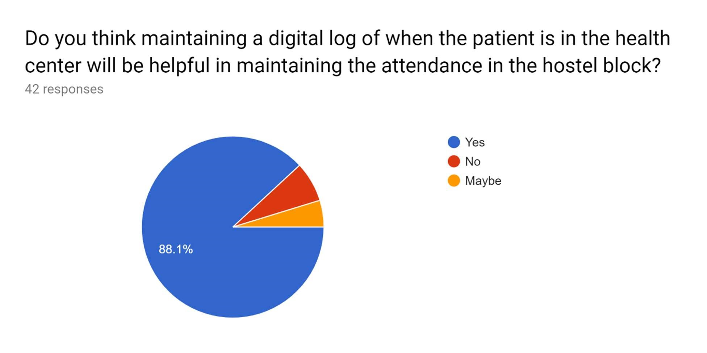

The response shows that almost everyone accepts that maintaining a digital log of the patient vesting hours can be helpful in marking attendance in their respective hostel blocks.

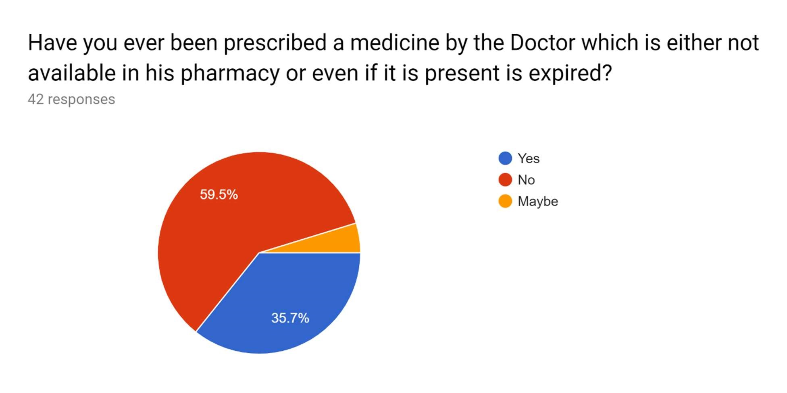

The response shows that a majority of the patients have not experienced such an issue at the CHC, but, 35.7% have said that they have experienced the issue which is large given the conditions.

The response clearly shows that almost all of the patients accept that they forget to take their medicines.

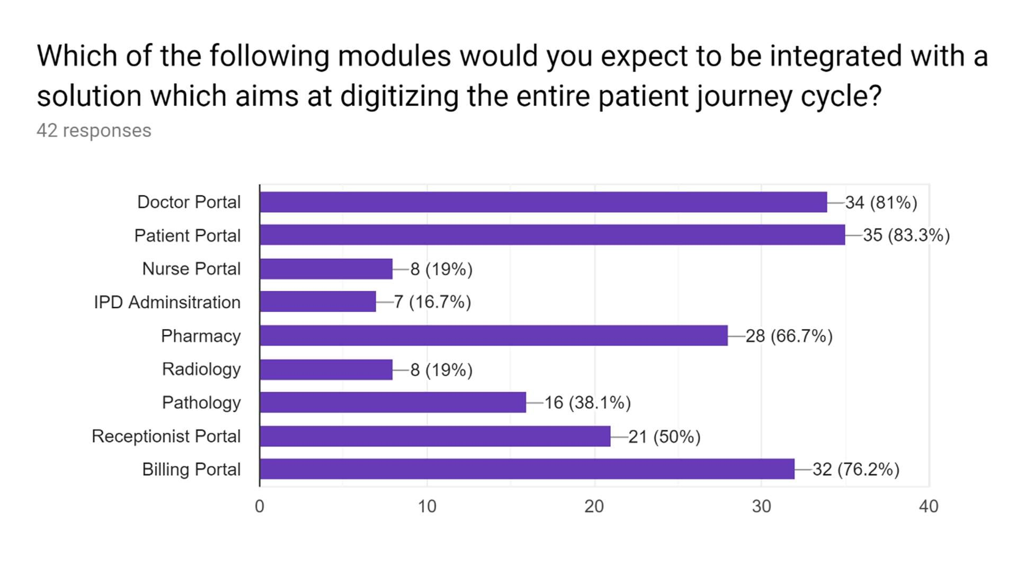

Patients want – a doctor portal, patient portal, digitized pharmacy and a digital billing portal.

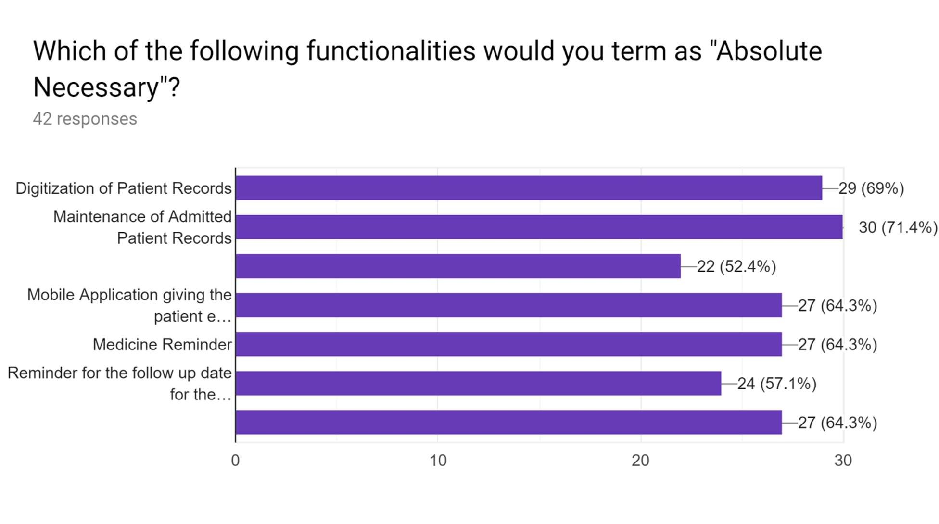

The response clearly shows that the patients want the system at the CHC to fully digitized. They believe that a digital implementation of the system would make it more efficient and transparent for every actor involved in the scenario.

Other than the modules and functionalities mentioned, suggest some additional functionalities you would expect.

|  |
| --- |
| Allow the patients to rate their experience with their doctors. |
| Nil |
| Whatever mentioned is great |
| Loads |
| None |
| Patient data can only be used by doctors and the patient itself. The data should also be visible to the student's parents. Data uploading on cloud can be done only after the patient has agreed to share the records on global basis. |
| None |
| None |
| A way that if there are many people in hispital then to reduce crowd messaging system to msg when they have to come. |
| None |
| Nothing |
| Whatever mentioned is great |
| NA |
| Nil |

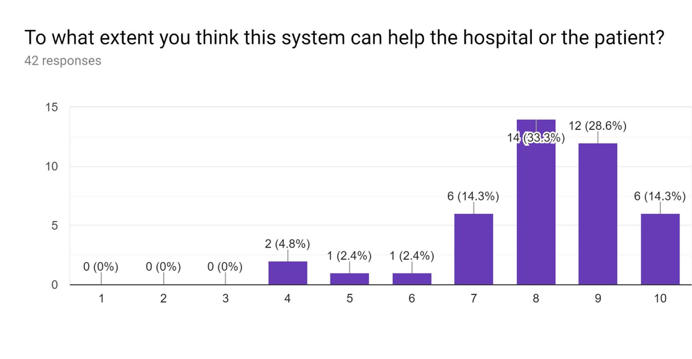

Briefly explain what would you expect in terms of hospitality from the health centre if you are a patient.

|  |
| --- |
| Fast appointments, abundant pharmacy |
| NIl |
| More specialized doctors |
| Good food |
| Doctor's availability |
| I want the rooms to be properly cleaned and the temperature of the room should be appropriate. A nurse should be assigned so that whenever we face some issues...we can call her |
| Loads |
| A well-managed system for the patient, less wastage of time |
| Kindness |
| Good health care |
| No |
| Nothing |
| Quick to respond and provide separate shuttle for patients from place if injury to health centre |
| Fast appointments, ease of use |
| Ease of use and reduction in waiting time |
| Ac rooms |
| Comfort and good ambiance |

|  |
| --- |
| Better management |
| Good behaviour and proper treatment |
| effective medication |
| None |
| Easy entry proper availability of bed and do tors |
| None |
| Free first aid, water/glucose, |
| Cheaper consultation |
| Nothing |
| Proficient doctors and a working pharmacy |
| Better treatment |
| I want the rooms to be properly cleaned and the temperature of the room should be appropriate. A nurse should be assigned so that whenever we face some issues...we can call her |
| NA |
| NA |
| Better crowd management and less waiting time. |
| None |
| Cool an hygienic environment. |
| Less time for my turn. |
| Quick Response and easy mobility. |

The communication with the staff should be easy, availability of doctors. Price should not be too high.

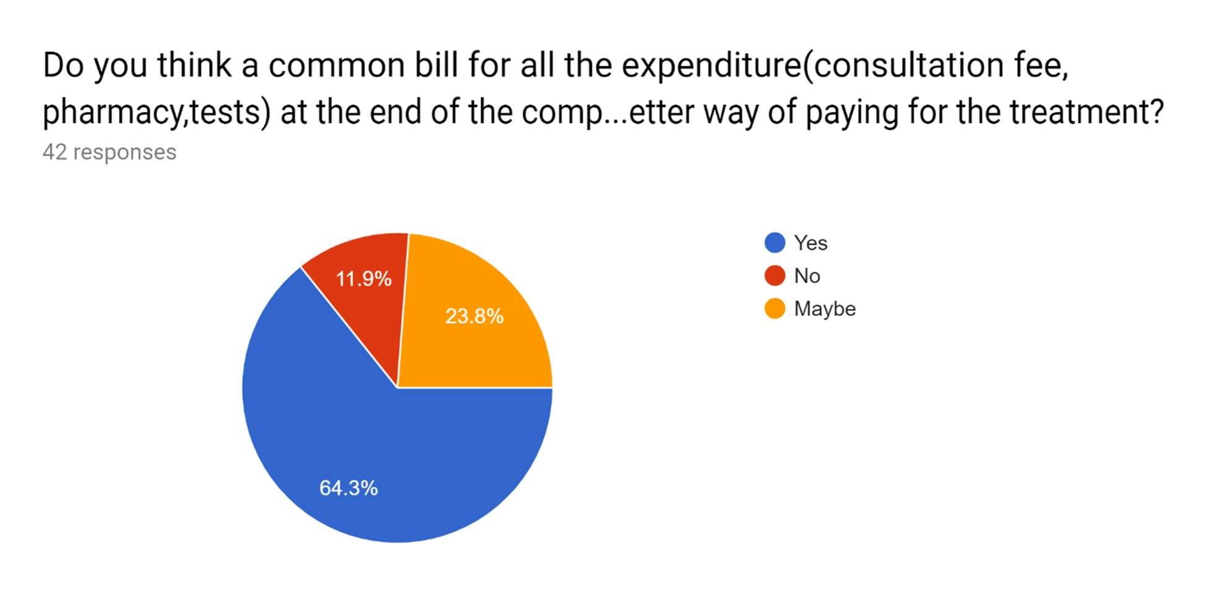

Most of the informed patients believe that a common bill covering all expenses, which is presented at the end of a consultation will be better for them.

DESIGN OF DIAGRAMS & PROTOTYPE DESIGN

• Use-case Diagram

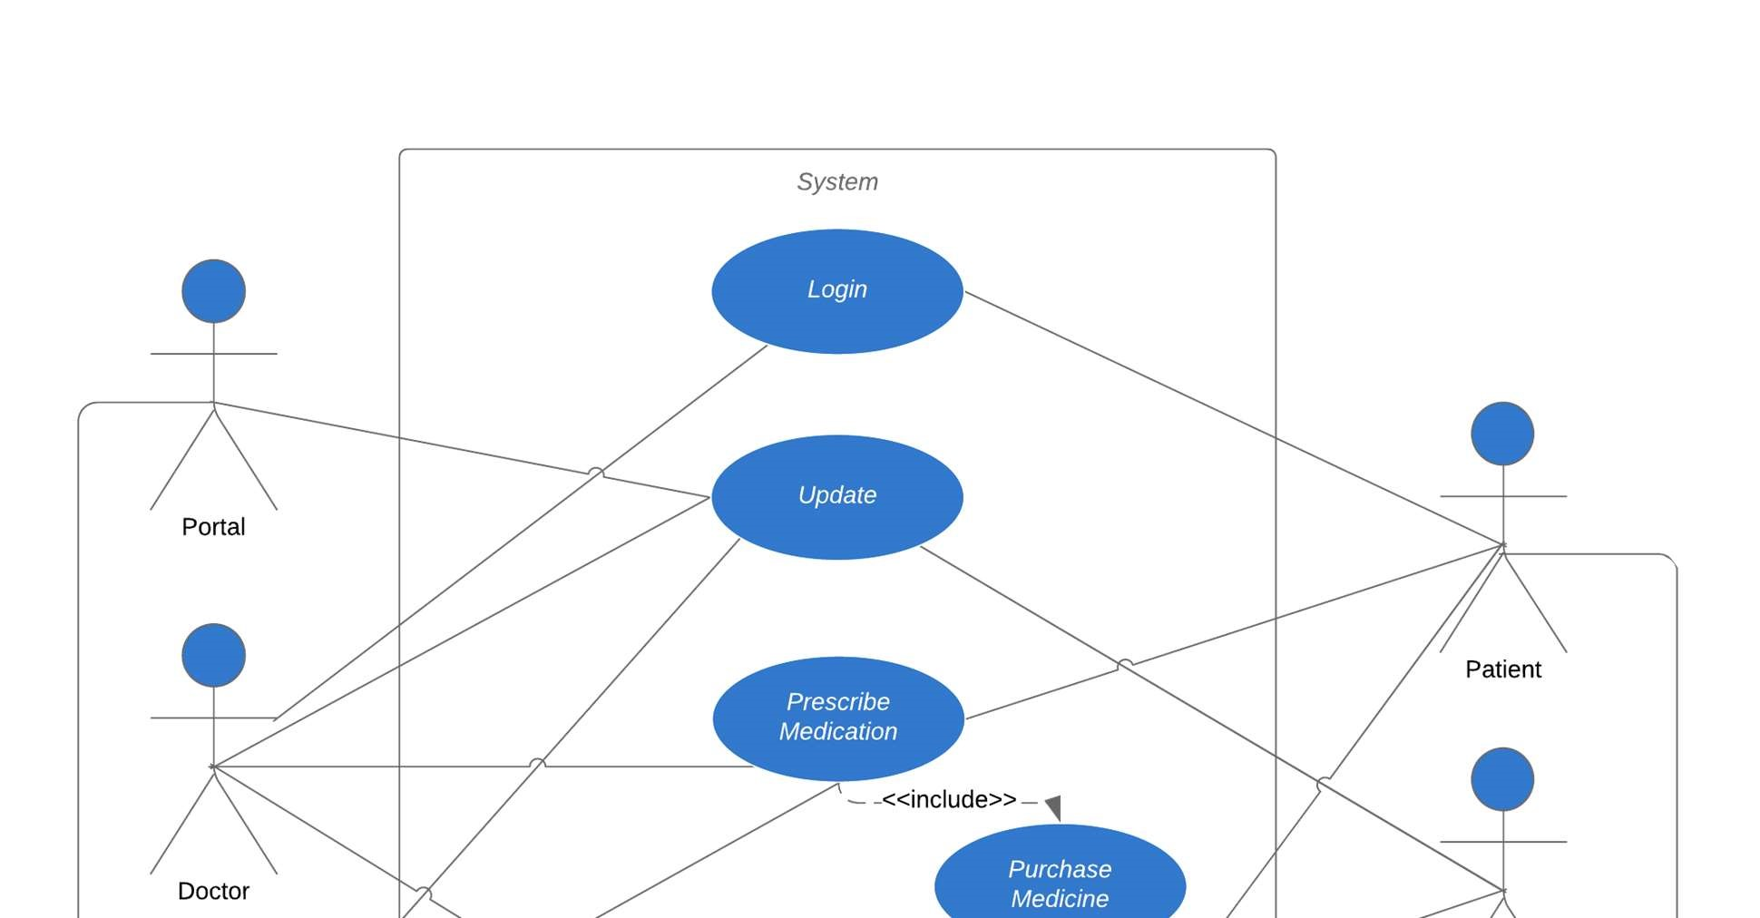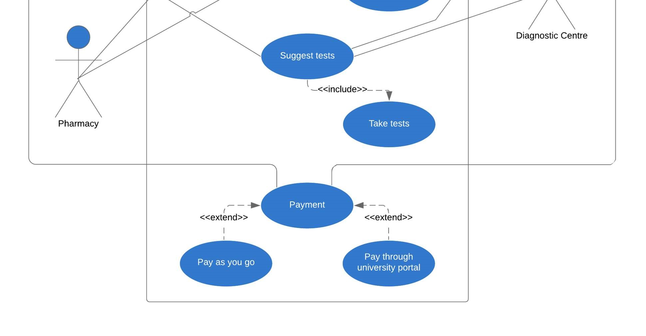

Activity Diagram

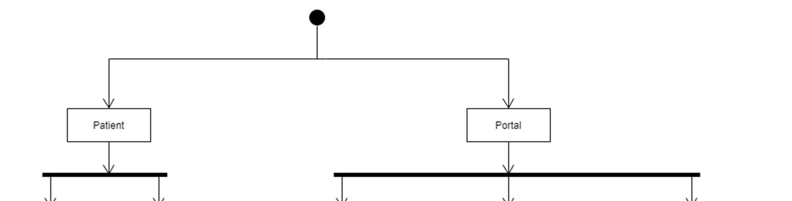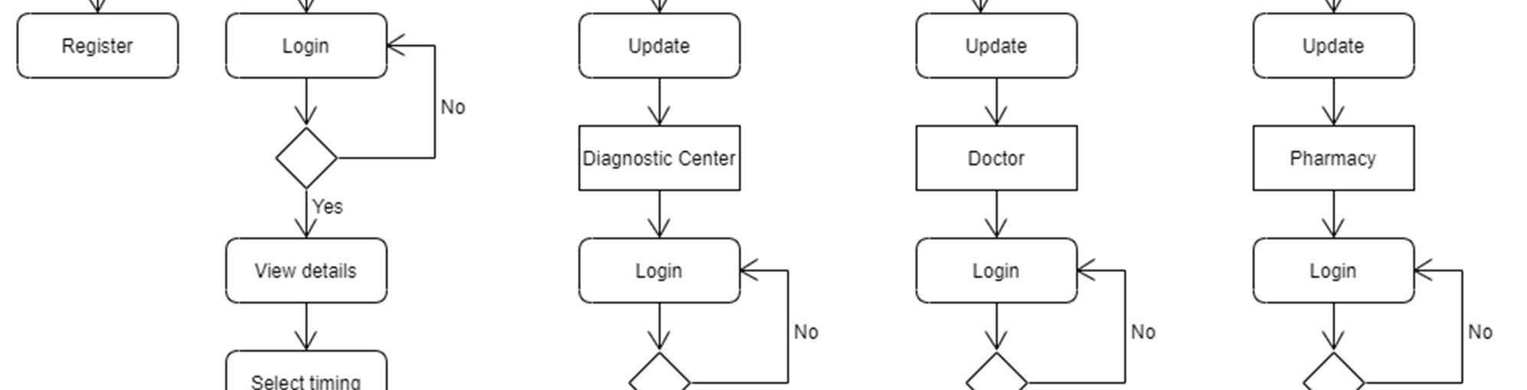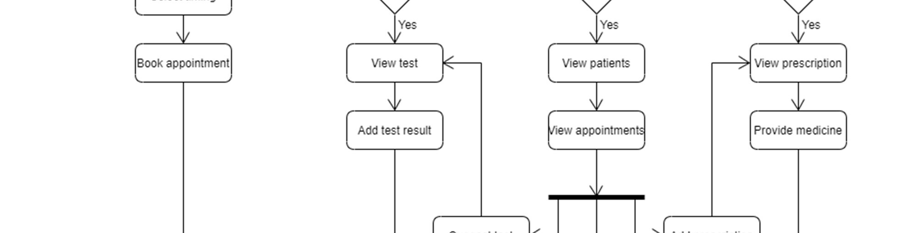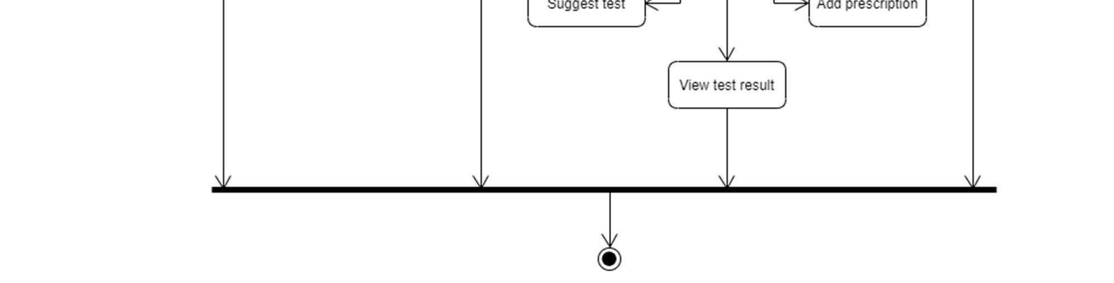

Sequence Diagram

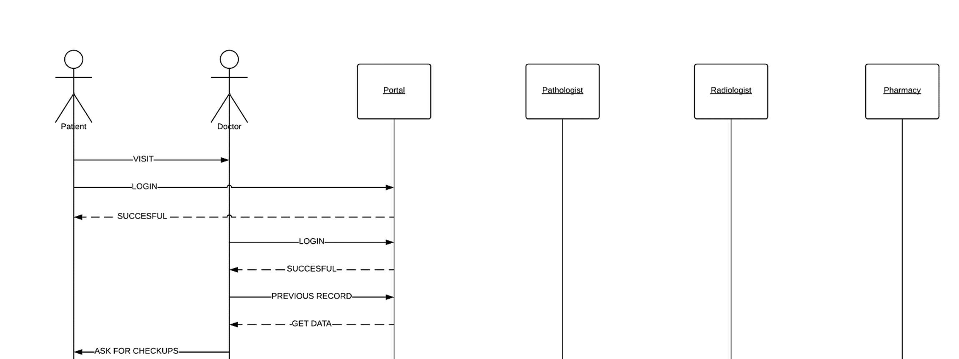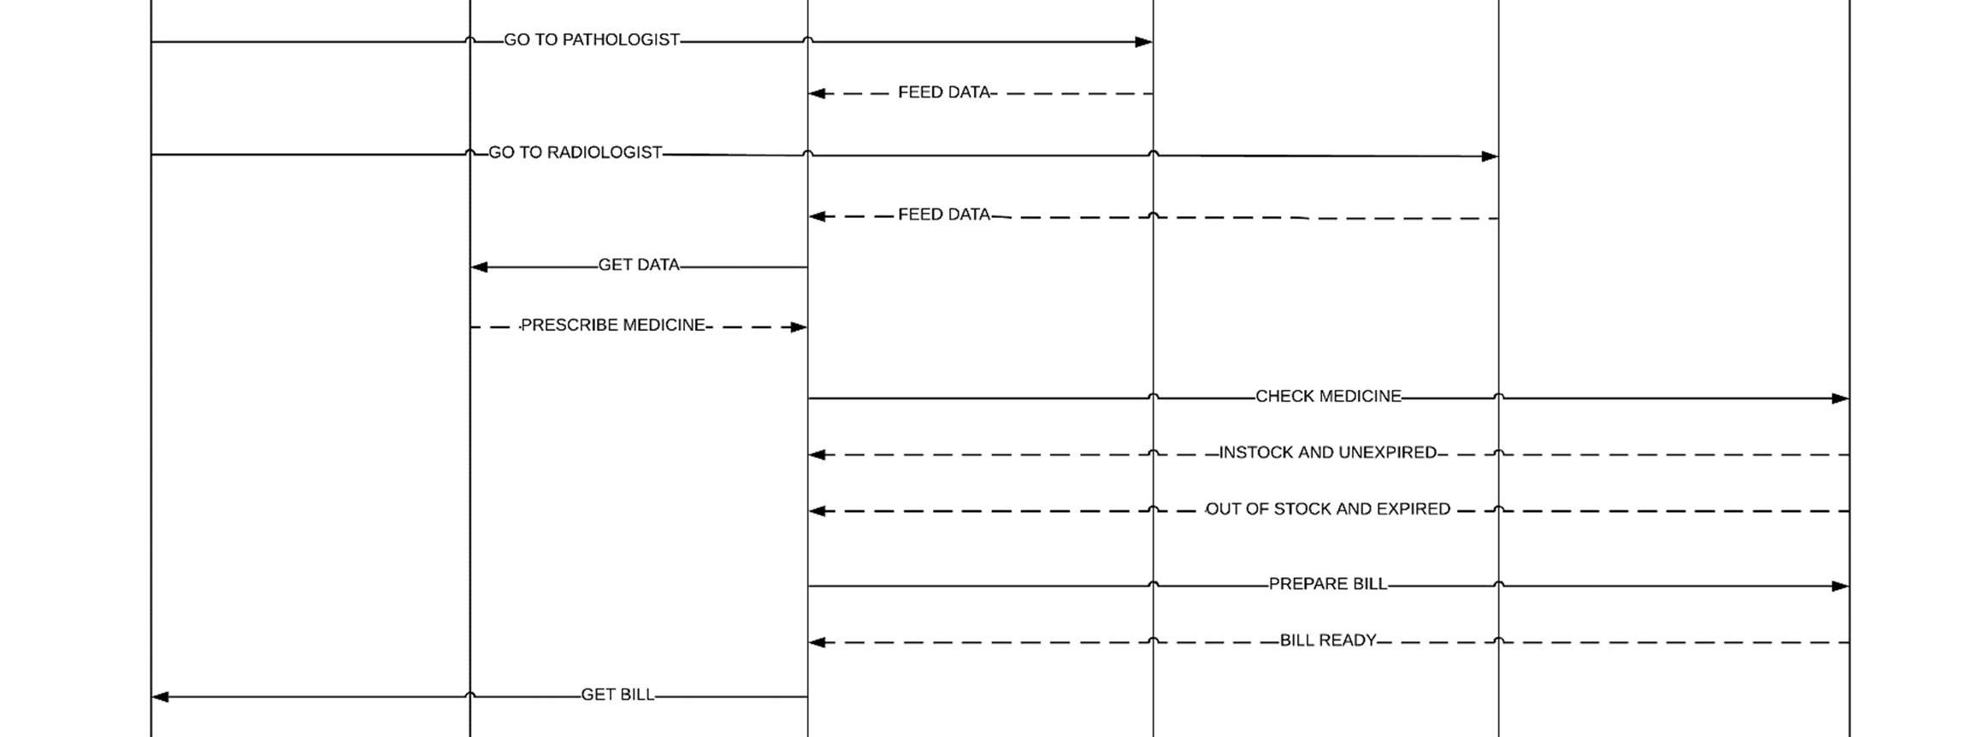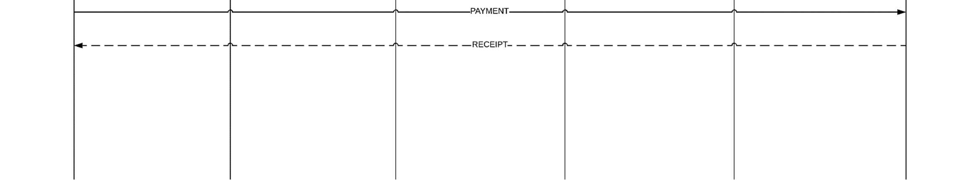

Class Diagram

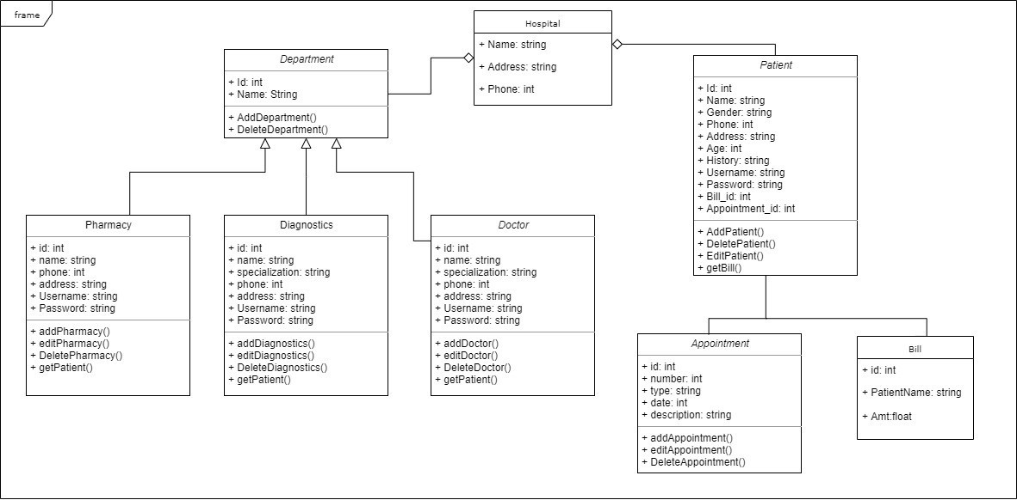

DEVELOPMENT OF A MODEL

Our proposed system aims at removing all the mentioned problems by digitization. A single web app will be existing where the Doctor is going to prescribe the medicines and input all the advice and problems the patient is facing. The web app will be used by all the people in the health center which will make sure that all the processes in the Patient Journey Cycle is digitized.

STAGE 1: The receptionist will enter the registration number of the patient into the Receptionist Portal which will put the patient in the OPD Queue.

STAGE 2: The OPD Queue is updated when the doctor sees a particular patient. After a patient’s turn in the OPD Queue comes, the patient goes to the doctor. The doctor can see his entire medical history in VIT in the Doctor Portal where he has to enter the Registration Number of the patient. The doctor after listening to his queries and recommending his diagnosis may suggest some tests.

STAGE 3: The next stage is the stage for the Pathologist. The pathologist conducts the tests prescribed by the doctor which is notified in the Pathologist Portal when he enters the Registration Number of the patient. After the test results have been obtained, the Pathologist feeds it into the Pathologist Portal for the Doctor to see.

STAGE 4: The next stage is the stage for the Radiologist. The scans are conducted by the technicians and the report is made by the Radiologist. The report is then entered into the portal.

STAGE 5: The next stage is revisiting the doctor after the Pathologist and the Radiologist reports are arrived and are entered into the system. The doctor can then view the reports which are added to the medical history of the patient. The doctor gives his final diagnosis and prescribes the medicine to the patient.

Note: As the entire medical inventory is digitized, the software will only allow the doctor to prescribe medicines which are in stock and are not expiring in the next 15 days. However, in case the medicine is not available in the pharmacy, the medicine will be written in a separate column in the generated bill.

STAGE 6: The patient is then sent to the pharmacy where he is given the medicines which are prescribed by the doctor.

STAGE 7: The patient pays all the money which has been added to his account right from the start of the transaction to the Health Center.

* Our software aims to digitise the entire solution. All the stages of the cycle are executed on a website and an android application. The best possible way for the patient to visit a health centre and make his visit and his overall experience of treatment much simpler and more likable.
* The project aims to create a web portal to make the hospital management system digitised. We have created a survey to check the main portals which will be the most useful for the patients and portals which the patients found would benefit the hospital in the best possible way.
* Basically, there will be two different kinds of logins. One is the Hospital Login and the second one is the Patient Login. The Hospital Login will be for all the hospital staff starting from the Doctor all the way down to the Nurse.
* The Patient Portal is for the patients who can see all their previous treatments and their prescribed medicines.
* The web portal of the website will have both the Hospital and the Patient login and the android version will have the Patient portal only which will enable the patient to have an easy to use solution and which will also intimate them about the medicines to be taken and the follow up date in order to go and meet the doctor again.
* The web portal will maintain a digital log of the patient vesting hours which can be helpful in marking attendance in their respective hostel blocks.
* Sometimes, patients may forget to take their medicines. The portal notifies the patient to take medicines in regular intervals.
* The portal notifies the patient to take medicines with follow-up date for the next appointment.
* The portal issues a common bill covering all expenses, which is presented at the end of a consultation which can be paid online using all modern mode of payments.
* Deployment Diagram

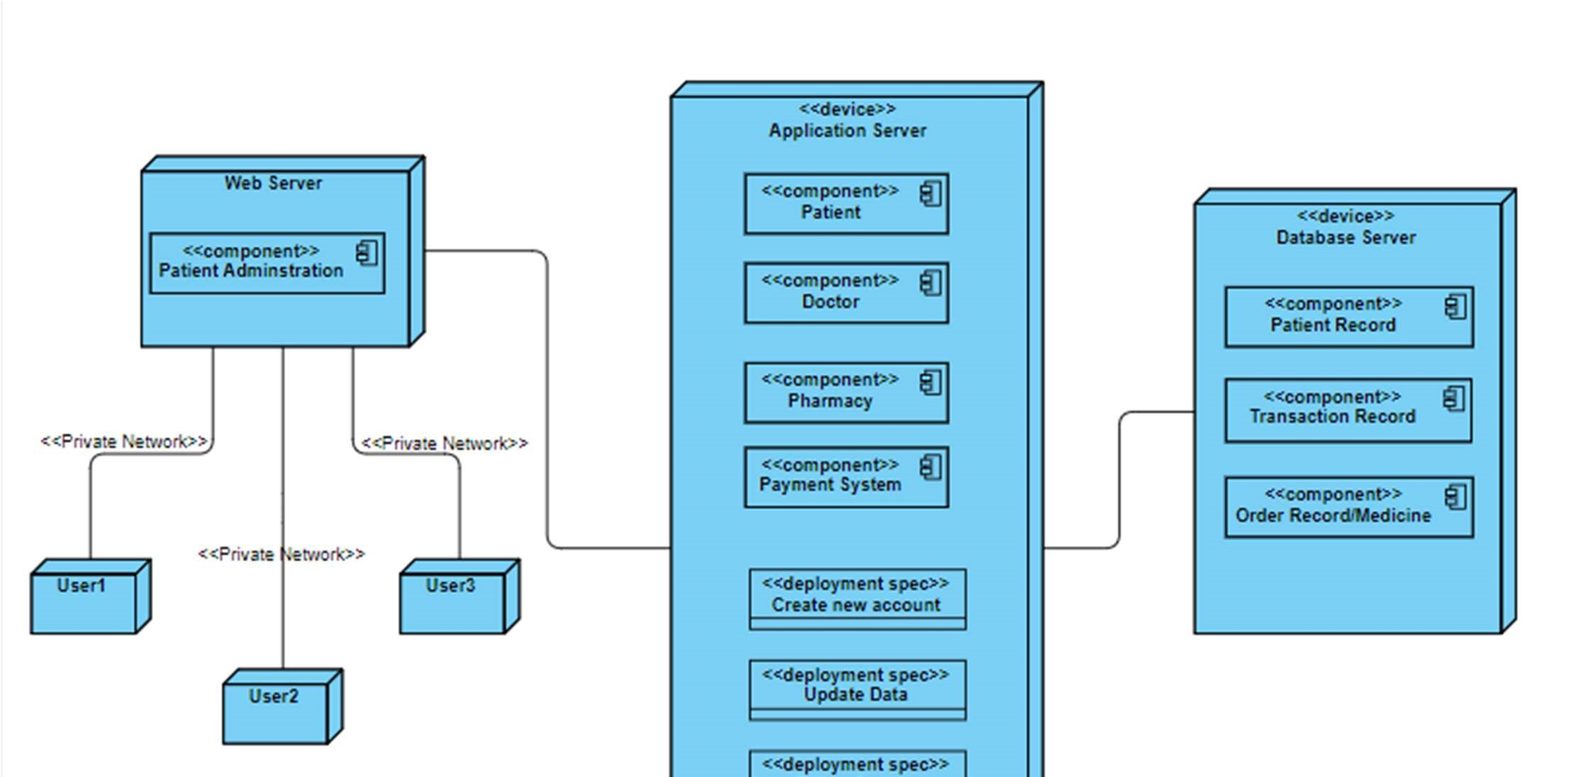

* Component Diagram

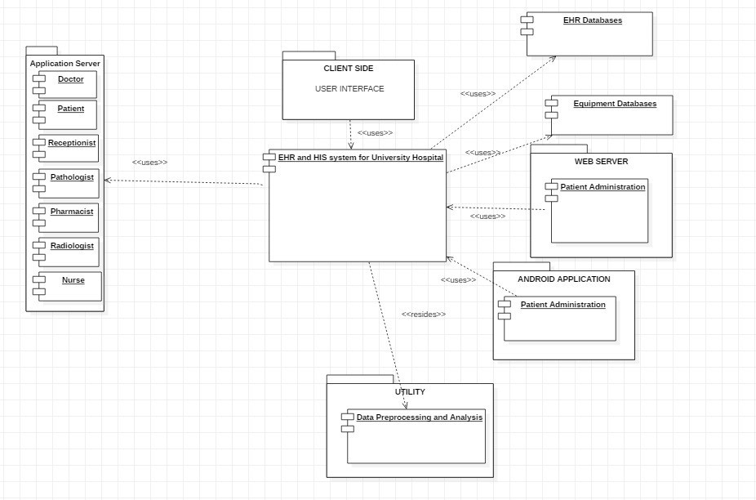

CONCLUSION

Our software aims to digitize the entire solution. All the stages of the cycle will be executed on a website and an android application. The best possible way for the patient to visit a health center and make his visit and his overall experience of treatment much simpler and more likable. The project aims to create a web portal in order to make the hospital management system digitized. We have created a survey in order to check the main important portals which will be the most useful for the patients and the portals which the patients found would benefit the hospital in the best possible way. Basically, there will be two different kinds of logins. One is the Hospital Login and the second one is the Patient Login. The Hospital Login will be for all the hospital staff starting from the Doctor all the way down to the Nurse. The Patient Portal is for the patients who can see all their previous treatments and their prescribed medicines. The web portal of the website will have both the Hospital and the Patient login and the android version will have the Patient portal only which will enable the patient to have an easy to use solution and which will also intimate them about the medicines to be taken and the follow up date in order to go and meet the doctor again.